Exporting Data to a Shape File in LRM
From within the Spatial View Window, select the feature(s) to be exported and Right Click in the Spatial View Window. Choose the option to ‘Send’ and then ‘Selection to Shape File’
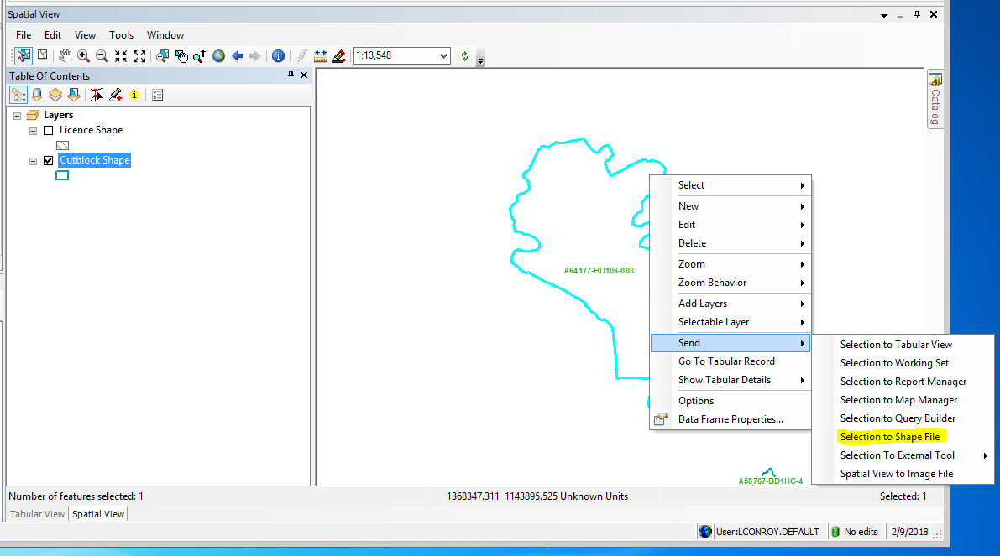

Export the ‘Selected features’ using the coordinate system as ‘this layers source data’ and browse to a location to save your data. Give the data a name and choose to Save as type: Shapefile and Save.
